Name of the Student | PRN
Priyanka Dhakate | 124B1F145
Pranav Shirode | 124B1F156
Geeta Kolte | 125B1F008

1.Mini Project Title:- Student Faculty Academic Portal (ER Diagram)
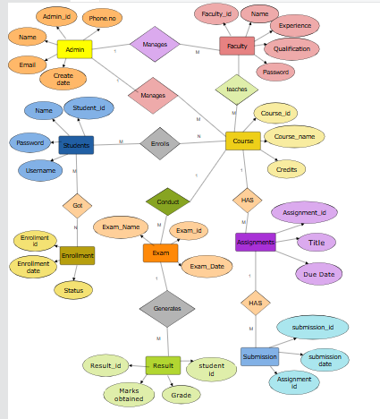

2.Mini Project Title:-Student Faculty Academic Portal(EER Diagram)

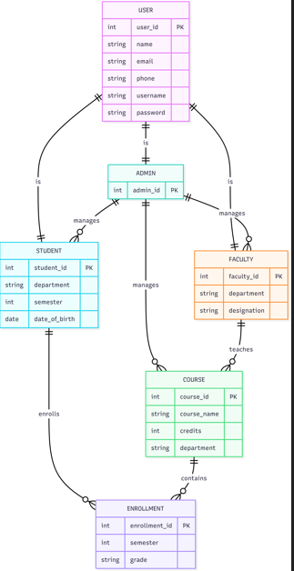

PRN :-124B1F145
3.Case Study:- Employee Performance Appraisal System(ER Diagram)

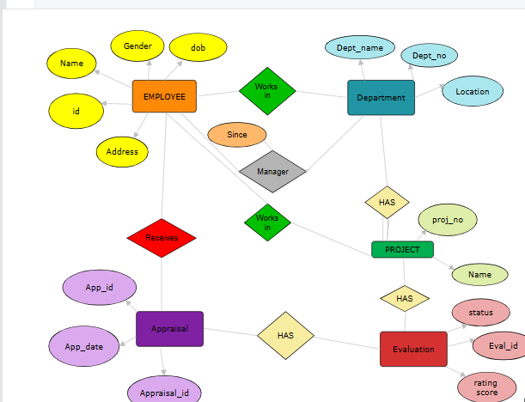

4.Case Study:-Employee Performance Appraisal System(EER Diagram)

